Small Business Inventory & Sales System
Architecture, algorithm, flowchart, tools, and AI build prompt

1. Overview
This project is a web-based inventory and sales management system for a Nigerian electronics store. The owner can add products, track inventory, record sales, manage customers and suppliers, see low-stock alerts, calculate profit, and view a dashboard summarizing daily and monthly performance.

2. System architecture
The system follows a three-tier architecture: a browser-based client, an application server holding the business logic, and a relational database.
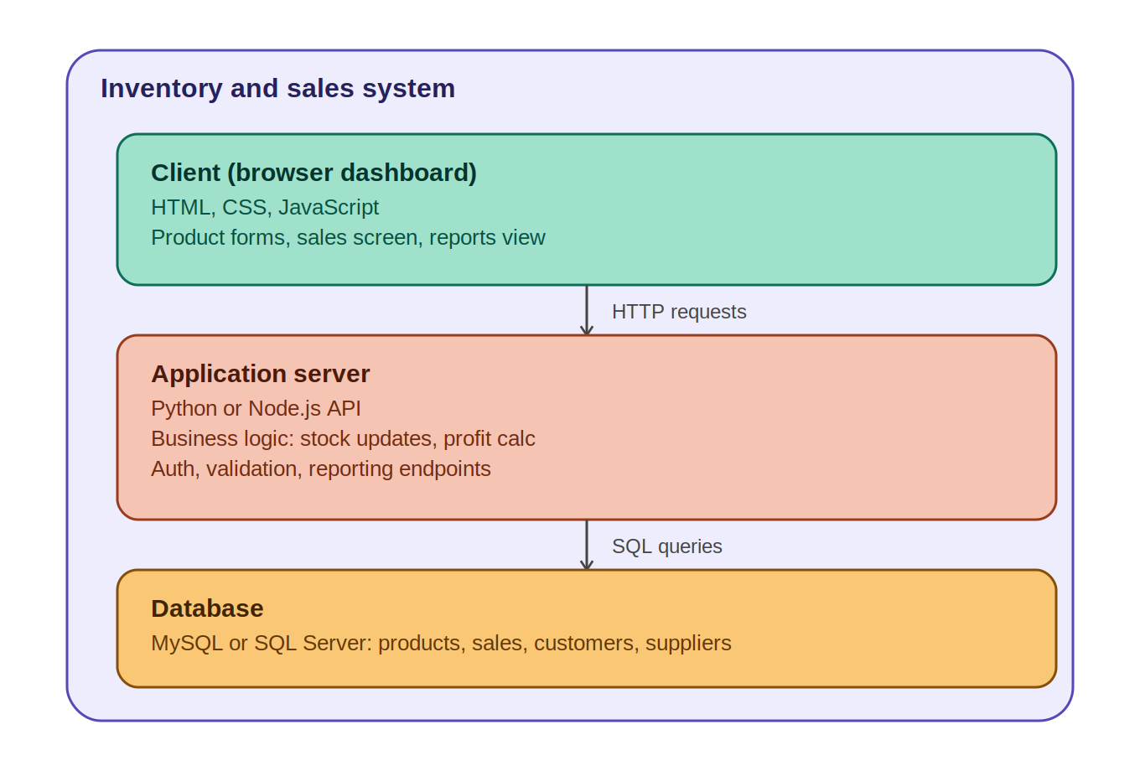
- Client (browser dashboard): HTML, CSS, and JavaScript render the product forms, sales screen, and reports view, and send HTTP requests to the server.
- Application server: a Python or Node.js API that validates input, applies business rules (stock checks, profit calculation), and handles authentication and reporting.
- Database: MySQL or SQL Server stores products, sales, customers, and suppliers, and is queried by the server via SQL.

3. Database schema
Design and create these tables first, with appropriate foreign key relationships:
Table | Fields
products | id, name, category, cost_price, selling_price, quantity_in_stock, reorder_level, created_at
customers | id, name, phone, email, address, created_at
suppliers | id, name, phone, email, address
sales | id, customer_id (nullable), sale_date, total_amount, total_profit
sale_items | id, sale_id, product_id, quantity, unit_price, line_total, line_profit
purchases | id, supplier_id, product_id, quantity, unit_cost, purchase_date

4. Core algorithm: recording a sale
This is the heart of the system — the process that runs every time a sale is recorded, touching inventory, profit, and the dashboard all at once.
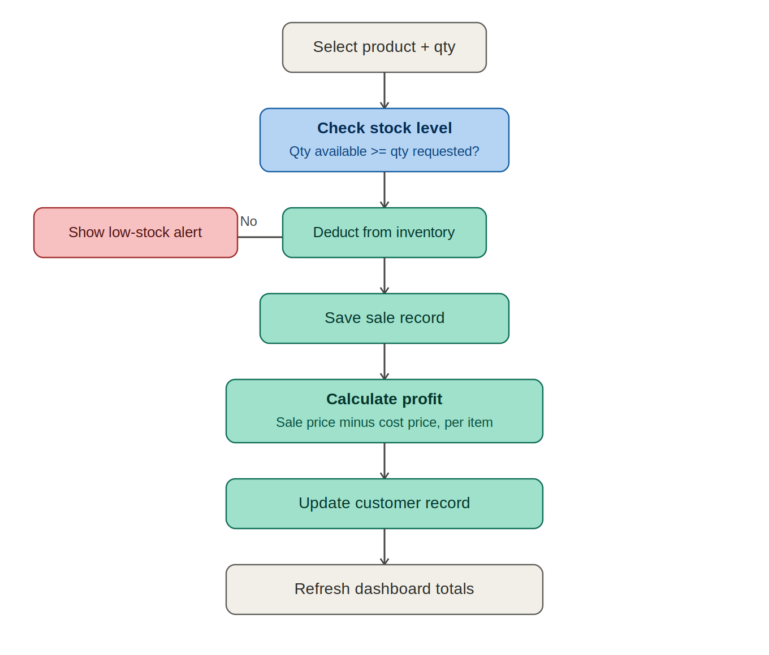

4.1 Step-by-step logic
- Owner selects a product and quantity to sell.
- System checks current stock: is available quantity ≥ requested quantity?
- If no — the sale is rejected and a low-stock alert is shown. Stock is never allowed to go negative.
- If yes — the requested quantity is deducted from inventory.
- The sale (and each line item) is saved to the database.
- Profit is calculated per line item as (selling price − cost price) × quantity, using the prices at the time of sale, not current prices.
- The customer's purchase history is updated (or the sale is marked as a walk-in).
- Dashboard totals (today's sales, products sold, low stock count) are refreshed.
Important: stock deduction and saving the sale should happen inside a single database transaction, so a failure partway through never leaves inventory and sales records out of sync.

5. Dashboard layout
The dashboard should summarize the business at a glance:
Today's Sales ₦1,250,000
Products Sold 37
Low Stock 8
Customers 24

Sales this month, grouped by product:
Product | Qty | Revenue
Laptop | 8 | ₦6,400,000
Monitor | 12 | ₦2,400,000
Keyboard | 17 | ₦850,000

6. Recommended tools & tech stack
Layer | Technology | Purpose
Frontend | HTML, Tailwind CSS, JavaScript | Dashboard, forms, sales screen — utility-first styling
Animation | Motion (motion.dev) | Number counters, card transitions, micro-interactions
Backend | Python (Flask/FastAPI) or Node.js | Business logic, API endpoints
Database | MySQL (or SQL Server) | Stores products, sales, customers, suppliers
Charts | Chart.js | Sales trend & product revenue visuals, animated by default
Hosting | Render / Railway | Backend + database hosting
Version control | Git + GitHub | Source control, portfolio visibility

MySQL is recommended over SQL Server for this project — it's free, widely supported, and easier to host on services like Railway or PlanetScale for a portfolio deployment.
Tailwind CSS drops in via a CDN script tag or a small build step — no need to abandon vanilla JavaScript to use it. Motion (formerly Framer Motion) also has a lightweight vanilla build, so neither addition requires switching to React.

7. Animations & UI polish
A few well-placed animations are what separate a working CRUD app from something that feels like a real product in a portfolio review. Keep every animation under ~400ms and purposeful — it should confirm an action or draw attention, not decorate.

7.1 Dashboard
- Animated number counters — today's sales, products sold, and customer count count up from 0 on load instead of appearing instantly.
- Stat cards fade and slide up in a staggered sequence (50–100ms apart) as the dashboard loads.
- Low-stock count pulses gently (a subtle scale/opacity loop) when the number is above zero, drawing the eye without being an alert-fatigue red banner.
- Chart.js's built-in animation is enabled by default for the monthly sales chart — bars grow from the baseline rather than popping in.

7.2 Sales & inventory actions
- Recording a sale triggers a toast/snackbar sliding in from the top or corner confirming the sale, then auto-dismissing.
- A rejected sale (insufficient stock) shakes the quantity input briefly and shows the error inline in red — an immediate, physical-feeling signal that something's wrong.
- Table rows for products highlight briefly (a soft background flash) when their stock is updated, so the owner can see exactly what changed after a restock.
- Hover states on buttons and product cards use a small scale (1.02×) and shadow lift — cheap to implement, makes the whole UI feel responsive.

7.3 Loading & transitions
- Skeleton loaders (pulsing gray placeholder blocks) while dashboard data or product lists are fetching, instead of a blank screen or spinner.
- Page/section transitions fade and slide content in rather than snapping between views, especially when switching dashboard tabs (Products, Sales, Customers, Suppliers).
Implementation note: Tailwind's built-in transition-* and animate-* utility classes cover hover states, fades, and skeleton pulses with no extra library. Reach for Motion specifically for the staggered card entrance, the number counters, and the shake/toast micro-interactions, where sequencing and easing control matter.

8. Suggested build order
- Set up the MySQL database and schema
- Build the Flask/FastAPI backend with REST endpoints for products, customers, suppliers
- Build the 'record sale' endpoint with the stock-check + transaction logic
- Build the dashboard summary endpoint (today's sales, low stock, monthly breakdown)
- Build the frontend consuming these endpoints
- Add Chart.js visuals for the monthly sales table/trend
- Polish: input validation, error messages, basic styling

9. AI build prompt
Copy the text below into your AI coding assistant (Claude Code, Cursor, etc.) to start building.

Project brief
Build a Small Business Inventory & Sales System for a Nigerian electronics store. The owner needs a web app to manage products, inventory, sales, customers, and suppliers, with a dashboard summarizing daily/monthly performance.

Tech stack
- Frontend: HTML, Tailwind CSS (via CDN or build step), vanilla JavaScript (keep it simple — no framework needed unless you want to add one later)
- Animation: Motion (motion.dev) for number counters, staggered card entrances, and micro-interactions; Tailwind's transition-*/animate-* utilities for hover states and skeleton loaders
- Backend: Python with FastAPI
- Database: POSTGRESQL
- Charts: Chart.js for the dashboard visuals, with animation enabled
- Currency: Nigerian Naira (₦), formatted with thousands separators

Database schema (build this first)
Design and create these tables with appropriate relationships and foreign keys:
- products — id, name, category, cost_price, selling_price, quantity_in_stock, reorder_level, created_at
- customers — id, name, phone, email, address, created_at
- suppliers — id, name, phone, email, address
- sales — id, customer_id (nullable for walk-in), sale_date, total_amount, total_profit
- sale_items — id, sale_id, product_id, quantity, unit_price, line_total, line_profit
- purchases — id, supplier_id, product_id, quantity, unit_cost, purchase_date (for restocking)

Core features to build, in this order
- Product management — add, edit, delete, list products with cost price, selling price, stock quantity, and reorder level
- Record a sale — select one or more products + quantities, auto-check stock availability, block the sale (with a clear message) if requested quantity exceeds available stock, deduct stock on success, save the sale + sale_items, link to a customer (or mark as walk-in)
- Customer management — add/view customers, and each customer's purchase history
- Supplier & restocking — add suppliers, record purchases from them, and increase product stock accordingly
- Low-stock alerts — a view/endpoint that lists all products where quantity_in_stock <= reorder_level
- Profit calculation — per sale item: (selling_price − cost_price) × quantity; aggregate for daily/monthly totals
- Dashboard — today's total sales (₦), products sold today, low-stock count, total customers, and a table of sales this month grouped by product (quantity + revenue)

Animation & polish spec
Keep all animations under ~400ms and purposeful. Implement these specifically:
- Dashboard stat cards (today's sales, products sold, low stock, customers) animate their numbers counting up from 0 on load using Motion, and fade/slide in with a staggered delay (50–100ms between cards).
- Recording a successful sale shows a toast notification sliding in and auto-dismissing after ~3 seconds.
- A rejected sale (insufficient stock) triggers a brief shake animation on the quantity input plus an inline red error message.
- Product table rows briefly flash/highlight when their stock is updated after a sale or restock.
- Buttons and product cards use Tailwind hover:scale-[1.02] and a shadow transition for hover feedback.
- Data lists show a Tailwind animate-pulse skeleton state while loading instead of a blank screen.
- Chart.js's default animation stays enabled so the monthly revenue chart bars grow in on load rather than appearing instantly.

Business logic rules
- A sale cannot be recorded if any line item's quantity exceeds current stock — reject with a clear error, don't allow negative stock.
- Stock is deducted only after a sale is successfully saved (wrap in a transaction so a failure doesn't leave partial updates).
- Profit is always calculated per line item at the time of sale (don't recalculate later from current prices, since prices may change).
- Low-stock threshold (reorder_level) is configurable per product, not a global constant.

Suggested build order
- Set up the POSTGRESQL database and schema
- Build the FastAPI backend with REST endpoints for products, customers, suppliers
- Build the 'record sale' endpoint with the stock-check + transaction logic above
- Build the dashboard summary endpoint (today's sales, low stock, monthly breakdown)
- Build the frontend with Tailwind CSS: a simple multi-page or single-page dashboard consuming these endpoints
- Add Chart.js visuals for the monthly sales table/trend
- Layer in Motion for the animation spec above (counters, stagger, toasts, shake, skeletons)
- Polish: input validation, error messages, final styling pass

Deliverable
A working local app (backend + frontend + database setup scripts/migrations) with a README explaining how to install dependencies, set up the database, and run it locally.
Please start by proposing the database schema and folder structure, then build incrementally, feature by feature, so I can test each part as it's completed.

